Steps to print the State Department Sticker from JIM

# Step 1:

In JIM, Go to Service 🡪 Reports🡪 Dispatch Reports 🡪 Click on State Dept. Sticker



# Step 2:

Enter the Label #, Number of Labels that need to be printed and Service Activity Number.

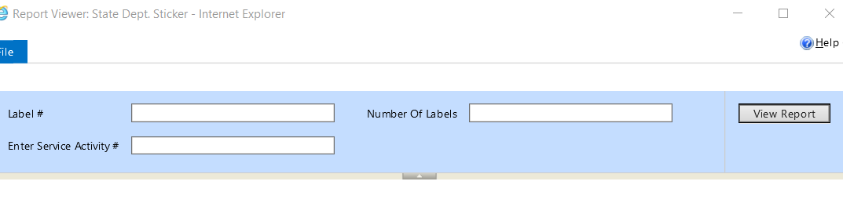

# Step 3

Click on the View report

# Step 4

Click on Print Button,

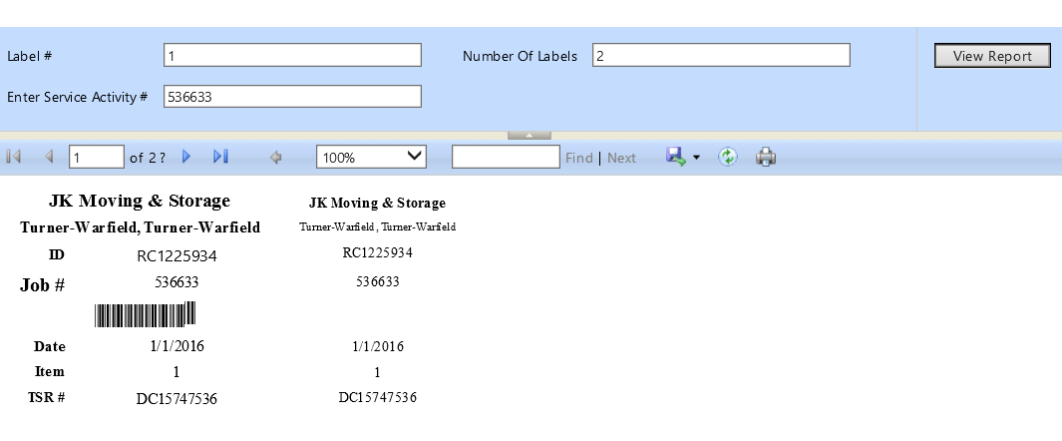

# Step 5

Choose the printer for printing the label**- Dispatch M1 Datamax**

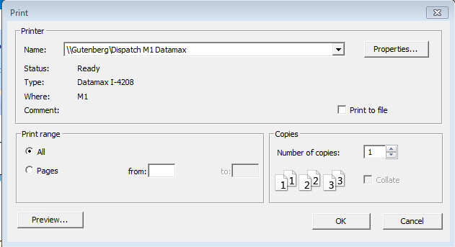

# Step 6

Click on Properties and make sure Name is set to **Multipurpose 4 x 2 (4.00in X 2.00in)** and the orientation is **Portrait. Click OK.**

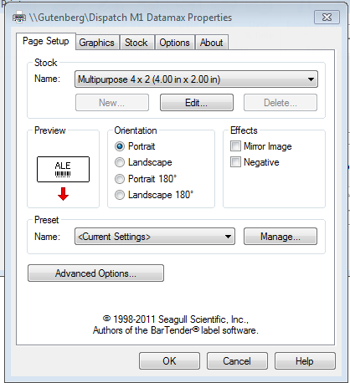

# Step 7

Click OK

